NATIONAL CHEMISTRY OLYMPIAD 2023

MARKING SCHEME PRELIMINARY ROUND 1

To be conducted from January 11 until Januari 27 2023

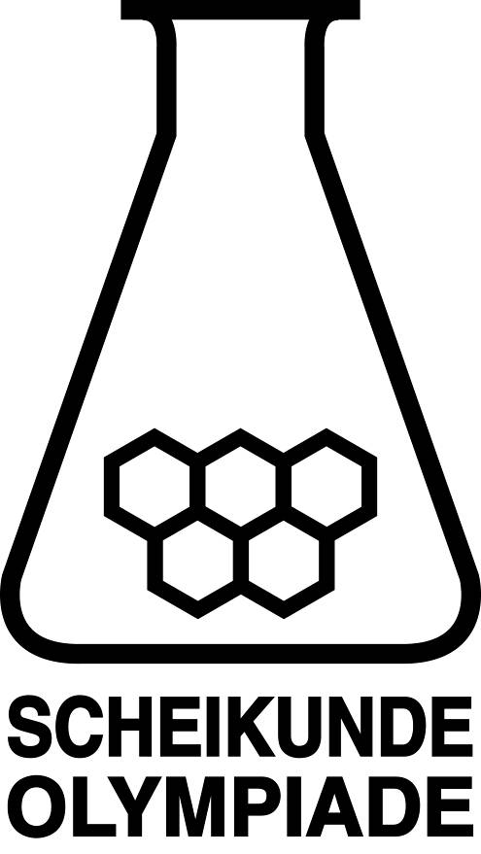



- This preliminary round consists of 20 multiple choice questions divided over 8 topics and 2 problems with a total of 14 open questions.
- The maximum score for this work is 77 points.
- Required materials: (graphic) calculator and BINAS 6th edition or ScienceData 1st edition or BINAS 5th edition, English version.
- For each question the number of points you can score are given.
- While assigning scores for the work, this marking scheme has to be used. Moreover the general rules for the Dutch Central Exams apply.

- Mutiple choice questions (total 40 points)

For every correct answer: 2 points
 |  | Carbon chemistry
1 | D | Glucose has the molecular formula C₆H₁₂O_{6.} Together, the two glucose molecules have 12 C, 24 H and 12 O. During hydrolysis, H₂O is added to one molecule of trehalose. Therefore one molecule of trehalose contains 12 C, 22 H and 11 O.
2 | E | 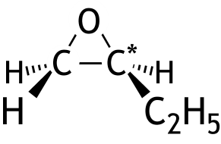  1,2-epoxybutane  C* is asymmetric, so two stereoisomers  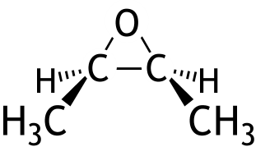  cis-2,3-epoxybutane  the mirror image is identical to the original,  so one stereoisomer  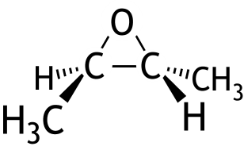  trans-2,3-epoxybutane  the mirror image is not identical to the original,  so two stereoisomers  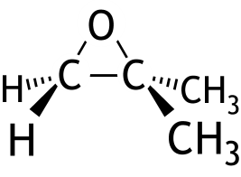  2-methylepoxypropane  the mirror image is identical to the original,  no asymmetrical carbon atom  so one stereoisomer
3 | G | With cyclopentene, only pentanedial is formed.  With pent-2-ene, ethanal and propanal is formed.  With hex-3-ene, only propanal is formed.

 |  | Reaction rate and equilibrium
4 | D | When the temperature is increased, the position of the equilibrium is shifted to the endothermic side, which in this case is to the left. The reaction to the right is therefore exothermic. At higher temperature, the equilibrium constant decreases and less H₂ is present during equilibrium at higher temperature when compared to lower temperature.
5 | F | When the volume is increased, the position of the equilibrium, when gases are involved, will shift to the side with the largest amount of mol of gas. That is the case in I and III.
6 | A | The rate at which NH₃ is produced, is .
 |  | Structures and formulas
7 | B | Magnesium sulfite is MgSO₃. The compound is made up of Mg²⁺ ions and SO₃^{2—} ions.  Between the Mg²⁺ and the SO₃^{2—} there is an ionic bond.  In the SO₃^{2—} ions there are atomic bonds present.
8 | C | 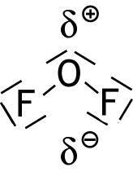  An OF₂ molecule is bent, just like a H₂O molecule. The fluorine atom has a larger electronegativity than the oxygen atom. So:
9 | D | The number of valence electrons of an S atom is 6 and of the five O atoms 5 × 6 = 30. Two extra electrons are responsible for the 2— charge. So there will be 38 electrons represented in the Lewis structure.
 |  | pH / acid-base
10 | E | From the K_{z} of NH₄⁺ follows:  .  The percentage conversion of NH₄⁺ ⁼ .
11 | B | The caustic soda contains 200 × 0.0657 = 13.14 mmol OH—.  The hydrochloric acid contains 140 × 0.107 = 14.98 mmol H⁺.  After the reaction between OH— and H⁺ is completed, the amount of H⁺ left over is 14.98 — 13.14 = 1.84 mmol.

 |  | Redox and electrochemistry
12 | B | The reaction equation is:  2 ClO₂(g) + 2 OH—(aq) → ClO₂—(aq) + ClO₃—(aq) + H₂O(l)
13 | C | Indium has the lowest V⁰ value and will therefore act as reducing agent. The electrons will move from the In electrode to the Co electrode through the wire, as indicated by arrow b.  The EMF is V_{ox} — V_{red} = — 0.28 V — (— 0.34 V) = 0.06 V.
 |  | Chemical calculations
14 | A
15 | C | Two examples of a correct calculation are:  Suppose there was x g silver and y g Cu in the 3.00 g alloy, then x + y = 3.00 (1).  mol Ag₃PO₄ arises and that is equal to g Ag₃PO₄ and  mol Cu₃(PO₄)₂ and that is g Cu₃(PO₄)₂.  So + = 4.25 (2).  (1) and (2) are a set of two equations with two unknowns. Solving this will produce x = 2.47.  There was therefore 2.47 g silver in the 3.00 g alloy, which is .  And  If the sample was made up of 100% silver, the residue would have contained only Ag₃PO₄ and the mass would be .  If the sample was made up of only copper, the residue would have contained only Cu₃(PO₄)₂ and the mass would be .  The mass of the residue is 4.25 g.  If the percentage mass of Ag is equal to y, interpolation will result in the following:  and y = 82%.

 |  | Thermochemistry and Green chemistry
16 | C | ΔH_{reaction} = ΔH_{formation, epoxyethane} — ΔH_{formation, ethene}  ΔH_{formation, epoxyethane} = ΔH_{reaction} + ΔH_{formation, ethene} = — 148 + (+ 52) = — 96 kJ mol^{—1}
17 | D | From 1 mole of 2-chloro-2-methylbutane, 0.77 mole of 2-methylbut-2-ene is produced.  m_{reactant} = 5 × 12.01 + 11 × 1.008 + 35.45 = 106.59 g  m_{product} = 0.77 × (5 × 12.01 + 10 × 1.008) = 0.77 × 70.13 = 54.00 g  So .
18 | G | Absolute values of the combustion enthalpies:  The enthalpy of combustion in J m^{—3} is proportionate to the enthalpy of combustion in J mol^{—1}, therefore that of methane is the largest.
   | in J mol^{—1} | in J kg^{—1} | in J m^{—3}
  Methane, CH₄ | 8.90·10⁵ |  | largest
  Methanal, CH₂O | 5.50·10⁵
  Hydrogen, H₂ | 2.86·10⁵ | So the largest.
 |  | Analysis
19 | C | In test 1 a gas is produced. NaOH and Ba(OH)₂ are then eliminated because upon reaction with an acid, H₂O is produced instead of CO₂, which is produced in the following reactions:  2 H₃O⁺ + CO₃^{2—} → 3 H₂O + CO₂(g)  H₃O⁺ + HCO₃— → 2 H₂O + CO₂(g)  In test 2 no precipitate is produced, therefore Pb(HCO₃)₂ can be eliminated because a PbI₂ precipitate would be produced. K₂CO₃ can also be eliminated because it would produce a BaCO₃ precipitate.
20 | F | In spectrum 2 the peak at m/z = 69 is an indication for CF₃⁺ and this only occurs in 1,1,1,2-tetrafluoroethane.  In spectrum 3 the peak at m/z = 30 is an indication for CH₂NH₂⁺. This only occurs in pentane-1,5-diamine.  The peak at m/z = 51 is also an indication for 1,1,2,2-tetrafluoroethane. Which is for CHF₂⁺, which will most probably occur at 1,1,2,2-tetrafluoroethane.  In spectrum 1 the peak at m/z = 51 is relatively the largest, it is therefore 1,1,2,2-tetrafluoroethane.

Open questions (total 37 points)
- Gold in solution 19 points
- Maximum score 3
- calculation of the [H₃O⁺] in aqua regia (equals the average molarity): 1
- calculation of the pH 1
- correct significance 1
- Maximum score 3
Au + 4 Cl— → AuCl₄— + 3 e— (×1)
NO₃— + 2 H⁺ + e— → NO₂ + H₂O (×3)
Au + 4 Cl— + 3 NO₃— + 6 H⁺ → AuCl₄— + 3 NO₂ + 3 H₂O
- equation of the half-reaction of Au is correct 1
- equation of the half-reaction of NO₃— is correct 1
- combination of both half-reaction equations into complete reaction equation 1
- Maximum score 1
An example of a correct answer is:
The V⁰ values are for 1.00 M solutions. The molarity of nitric acid in aqua regia is much higher.
Note:
When an answer is given like: „The V⁰ values are for a temperature of 298 K; the temperature during the reaction of gold with aqua regia could be different.”, give full marks.
- Maximum score 3
3 AuCl₂— 2 Au + AuCl₄— + 2 Cl—
- Au balance correct 1
- Cl balance correct 1
- charge balance correct 1
If the following equation is given:
2 AuCl₂— Au + AuCl₄— + Cl— 1
- Maximum score 3
- calculation of the amount of mmoles of S₂O₃^{2—} that was used for the titration: multiply 5.34 (mL) with 0.0100 (mmol L^{—1}) 1
- calculation of the amount of mmoles of AuCl₄— in the investigated solution (equals the amaunt of mmoles of I₂ produced): divide the amount of mmoles of S₂O₃^{2—} that was used for the titration by 2 1
- calculation of the [AuCl₄—] in the investigated solution: divide the amount of mmoles of AuCl₄— in the investigated solution by 10.00 (mL) 1
- Maximum score 2
An example of a correct answer is:
After the titration, all of the Au has ended up as AuI, so the amount of mmoles of AuI is the sum of the amount of mmoles of AuCl₂— and the amount of mmoles of AuCl₄— in the 10.00 mL sample.
- notion that after titration, all Au has ended up as AuI. 1
- conclusion 1
- Maximum score 2
An example of a correct answer is:
The solution has to be electrically neutral, therefore:
[H₃O⁺] = [AuCl₂—] + [AuCl₄—] + [Cl—]
- notion that solution must be electrically neutral 1
- conclusion 1
- Maximum score 2
An example of a correct answer is:
No, because gold is a solid and solids are not included in the reaction quotient / equilibrium condition.
- cold is a solid 1
- solids are not included in the reaction quotient / equilibrium condition and conclusion 1
If answer is given like: „No, because gold is a solid and solids are not included in the equilibrium constant.” 1
Note:
When an answer is given like: „No, because gold is a solid and you cannot determine the concentration of solids in a solution”, give full marks.
- Click chemistry 18 points
- Maximum score 2
An example of a correct answer is:
They are not stereoisomers because the R₁ is located on different positions in the two molecules.
- the R₁ group is located on different positions in the two molecules 1
- conclusion 1
- Maximum score 5
Examples of correct answers are:
- calculation of the molar masses of the alkyne (132.15 g mol^{—1}) and the azide
(133.16 g mol^{—1}) 1
- calculation of the amount of g of azide that reacts with 10 g of the alkyne: the molar mass of the azide divided by the molar mass of the alkyne, and the quotient multiplied by 10 (g) 1
- calculation of the total mass of the products that are produced during 100% completion (is equal to the total mass of the starting materials): 10 (g) added to the amount of g of azide that reacts with 10 g alkyne 1
- calculation of the amount of g of anti-product that is produced during 100% completion: the total mass of the products that are produced during 100% completion multiplied by 1.6 and divided by 2.6 1
- calculation of the conversion percentage: 11 (g) divided by the amount of g of anti-product that is produced during 100% completion and multiplied by 100% 1
and
- calculation of the molar masses of the alkyne (132.15 g mol^{—1}) and the azide
(133.16 g mol^{—1}) 1
- calculation of the amount of g of azide that reacts with 10 g of the alkyne: the molar mass of the azide divided by the molar mass of the alkyne, and the quotient multiplied by 10 (g) 1
- calculation of the total mass of the products that are produced during 100% completion (is equal to the total mass of the starting materials): 10 (g) added to the amount of g of azide that reacts with 10 g alkyne 1
- calculation of the amount of g of syn-product that is produced experimentally: 11 (g) divided by 1.6 1
- calculation of the conversion percentage: the amount of g of syn-product that is produced experimentally, added to 11 (g) and the sum divided by the total mass of the starting materials, and the quotient multiplied by 100% 1
and
moles of alkyne react. So during 100% completion, a total of moles of anti-product and syn-product should be produced. Suppose that x moles of syn-product are produced, then 1.6 x moles of anti-product are produced.
Therefore , which produces x = 0.0291. During 100% completion 1.6 × 0.0291 moles of anti-product will be produced. Which is 1.6 × 0.0291 × 265.31 = 12.4 g.
There is 11 g, therefore the conversion percentage was .
- calculation of the molar masses of the alkyne (132.15 g mol^{—1}) and the product (265.31 g mol^{—1}) 1
- calculation of the total amount of moles of anti- and syn-product that is produced (which is equal to the amount of moles of alkyne that has reacted): 10 (g) divided by the molar mass of the alkyne 1
- calculation of the amount of moles of syn-product that has been produced during 100% completion: solve for x from 1
- calculation of the amount of g of anti-product that is produced during 100% completion: the amount of moles of syn-product that is produced during 100% completion multiplied by 1.6 and by the molar mass of the product 1
- calculation of the conversion percentage: 11 (g) divided by the amount of g of anti-product that is produced during 100% completion and multiplied by 100% 1
- Maximum score 2
An example of a correct answer is:
Principle 2: Two products are formed in the reaction without a catalyst. In this case the atom economy is lower than 100%. In the reaction involving a catalyst all atoms end up in the product. In this case the atom economy is 100%.
Principle 6: The reaction involving a catalyst (is faster and) takes place at a lower temperature when compared to the reaction without a catalyst.
- argument for principle 2 is correct 1
- argument for principle 6 is correct 1
- Maximum score 2
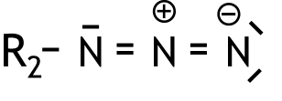

- there is a double bond between the N atom on the left and the N atom in the middle and there is a double bond between the N atom in the middle and the N atom on the right 1
- non-bonding electron pairs and charges in the correct position 1
- Maximum score 4
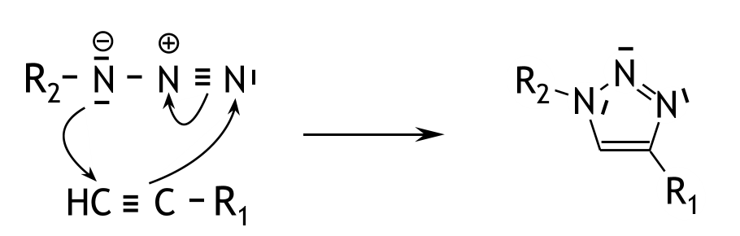
An example of what a correct answer could look like:

- curved arrow from the nitrogen atom on the left (in the azide) to the carbon atom on the left (in the alkyne) 1
- curved arrow from the triple bond in the alkyne to the nitrogen atom on the right (in the azide) 1
- curved arrow from the N ≡ N to the nitrogen atom in the middle 1
- non-bonding electron pairs in the product are presented correctly 1
If in an otherwise correct answer, the mechanism for the formation of the syn-compound is provided, for example:
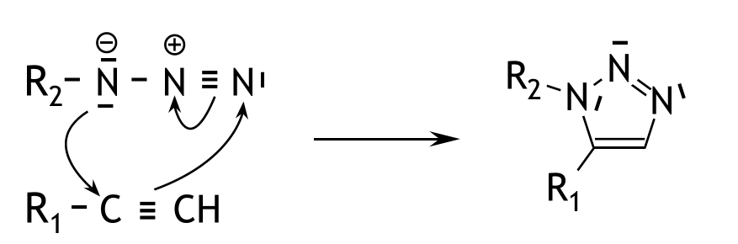

3

- Maximum score 3
The substances used are:
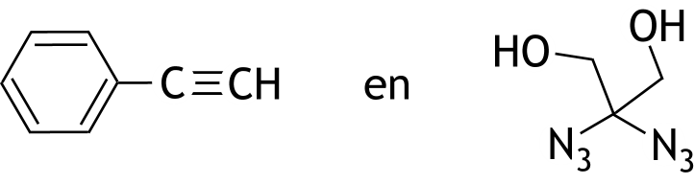

A copper(I) catalyst is used.
- correct structure of the alkyne 1
- correct structure of the diazide 1
- a copper(I) catalyst is used 1

